horizontal line

**SOAD PROJECT PROPOSAL**

Senior Sunshine

# OVERVIEW

In several parts of the world, there is an increasing elderly population and they are being isolated, having difficulties performing daily tasks and activities. This is actually an ongoing problem before the pandemic, but when COVID-19 hit, it got worse. We hope that by connecting available proactive young adults to help out with the seniors in their community, we can foster an environment where the elderly won’t be isolated from the community and can form and maintain relationships with the younger generations. There is so much wisdom and meaningful experiences that seniors can share with the younger generation and we hope this website can help foster the connectivity and sharing of meaningful experiences too!

# GOALS

1. Connect seniors with young volunteers
2. Have a clean, user-friendly UI to make it accessible and easy for the seniors to interact with the website

# SOLUTION

We aim to create a website that connects seniors with young volunteers to help them with their daily tasks, activities and also have a buddy to talk to when they want company.

# REQUIREMENT ANALYSIS

Wireframes, Color scheme, Simple and minimalistic UI

Home Page: Simple UI, big buttons and font, header, footer

Signup/Login for seniors: name, age, phone number, address

Signup/Login for volunteers: name, age, gender, phone number, address, availability times, services which they are available for

Verification of volunteers legitimacy: Primary verification is by Aadhar (for Indians), background can be checked too (using an API, but we should find a free service)

Form for seniors: When do you need help, what do you need help with

Matching seniors to volunteers: Based on the form inputs, we match the seniors with available volunteers

Request fulfillment: When a request has been fulfilled, both the seniors and the volunteer will click on a ‘fulfilled’ button. This will add the experience into the profile of the volunteer

Profile page for volunteers: Shows all the details which have been taken during the signup process (Can also include a profile picture)

Profile update for volunteers: Details entered during the signup process can be updated

Map: List of pending requests in the form of markers

Our Team/ Contact Us: Kind of like a helpline page, just to get in touch with the team for any queries

**Services we provide: endpoints**

api/profile/add (post) -- private -- only the volunteer can create his/her profile

api/profile/user/:user_id (get, put, delete) -- get (public), put, delete (private) -- any user can see the volunteers profile. Volunteers can update or delete his/her profile.

api/profile/all (get) -- public -- any user can see the list of volunteers

api/services/all (get) -- public -- any user can see the list of available services/tasks

api/services/:service_id (get, put, delete) -- get (public), put, delete (private) -- any user can get the info of a particular service. Admin can update or delete a particular service.

api/services/add (post) -- private -- only the admin can add a service to the database.

**Links to the swagger.io files:**

Volunteer Profile: [Volunteer Profile](https://app.swaggerhub.com/apis/Jagruthi/Volunteer_Profile/1.0.0)

Services: [Services](https://app.swaggerhub.com/apis/Jagruthi/Services/1.0.0)

Where can our services be used? They can be used in old age homes or at hospitals where the elderly are looking for company or help. They can connect with our team and get help whenever they need it or can schedule them regularly.

**Services we consume:**

Google Maps API , Google directions API (for the map feature)

User authentication with Auth0 or Django

Some kind of a notification API can also be included (to send messages when a match is made)

Some API which enables click-to-call functionality

**PLANNED TECH STACK**

* **Front-end:** ReactJS
* **Back-end:** Django REST
* **DataBase:** Firebase

# RISK ANALYSIS

We have to verify the details of the volunteers to make sure that they are legit and are willing to help seniors and not just for malicious purposes. For which, we plan on going through the following links and explore more on if we could make it more secure.

<https://aadhaarapi.com/>

<https://www.zoop.one/identity-verification/> => pan card, driving, voter id

<https://www.searchbug.com/api/criminal-background-check.aspx> (not free)

<https://www.accurate.com/solutions/background-check-api/> (not free)

<https://www.quora.com/Is-there-a-background-check-company-that-offers-API-to-integrate-with-my-site>

We can’t satisfy users of all **languages/regions.** Though we could use some plugins or services which will help us with this. It is not possible to finish it within the given time, however, it could be extended outside the semester if we get good traction on our prototype.

# PLAN

# Plan:

Wireframes, Color scheme

Implementation of features listed below

**FEATURES:**

* User Authentication
  + **Senior Signup** -- Name, age, phone number, address (The data will be private but volunteers can see the address of the seniors on the map)
  + **Volunteer Signup** -- Fill all the form details and then get a background check done
  + **Volunteer Login** -- Once logged in, redirected to a page where they can see the current requests by seniors (unmatched ones)
  + **Profile details** --
    - Name, Age, Gender, Phone number, Address
    - Availability times
    - Services they are available for
      * Profile details will be initially taken during the registration
      * Profile update option for volunteers
* Matching seniors to volunteers according to the services
* **Request fulfillment** -- Both the senior and the volunteer have accepted the match and the request has been fulfilled
* Getting **review** on the service (a survey sent out once a month)
* **Instant call feature** which helps the seniors to connect with their volunteers easily.

**Workflow:**  
**Senior:**  
- They open the webpage and choose the **'Get Help'** option.  
- They will then be redirected to a signup/login page.  
- After signup/login, they will be redirected to a form where they can choose the services needed and fill in the current location.  
- After submitting the form, they will be shown a list of available volunteers who satisfy the criteria above.  
- Then the senior can go through all the profiles of the volunteers and then select one based on their preference  
- Once selected, the senior can connect with them over a call.  
- If both the parties confirm, a match is made and they'll be notified of each other's details.  
- If none of the volunteers are satisfactory, the senior will then be placed on a map where the volunteers can click on the marker to see the senior's needs.  
- If there are any unfulfilled requests, the volunteers can check them on the map and contact the senior.

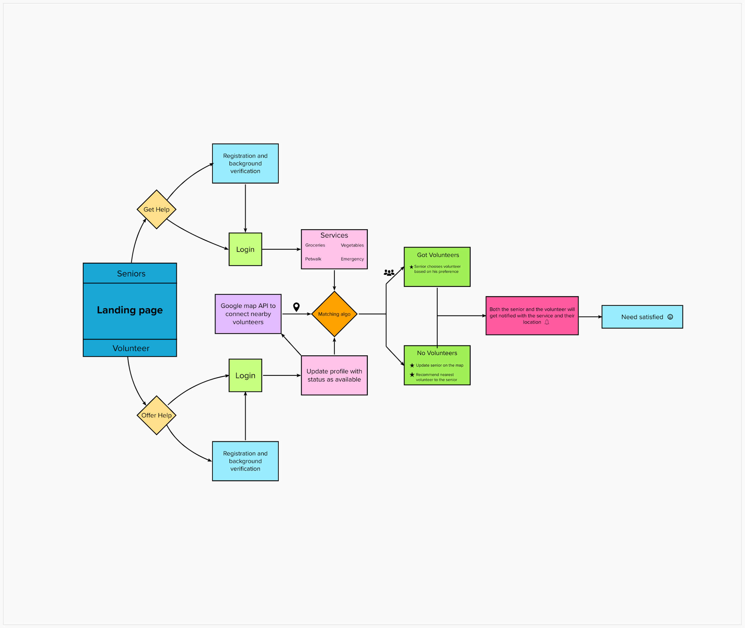

**Volunteer:**  
- They open the webpage and choose the **'Offer Help'** option.  
- They will then be redirected to a signup/login page.  
- They can also see the location of the seniors on the map.  
- If a match has been made and fulfilled, then it will be added to his/her profile as an experience (points).  
- This experience would help the seniors to choose whom to rely upon in a better way( more points more trustworthy ) - They can also see the requests that are currently taken up and yet to be fulfilled or which have been fulfilled on his/her profile.  
  
**MARKET ANALYSIS**

In April 2019, for the first time ever, there were more people over 60 in the U.S. than under 18. The number of older persons is expected to double by 2050 when it is projected to reach nearly 2.1 billion.

No matter where a senior lives, they face the possibility of isolation and loneliness. Too often, a senior finds themselves in a situation where their family lives many miles away and their network of friends has dwindled until they have no one to spend time with. This level of isolation can lead to health issues and depression.

Staying connected and fighting isolation is important for every age group, and for seniors, it is doubly important. With today’s technology, there is help available for every senior in our community, so they don’t let loneliness creep in and take over.

At the Hebrew University of Jerusalem, researchers surveyed over 1400 pre-teen and teenagers from ages 12 to 18. They discovered that those with close relationships with seniors had less emotional issues and better social skills as well as less tendency towards violence.

**Business logic/POV**:   
- Seniors have to pay a minimal amount to get recurrent/periodic support from a particular volunteer. - Two free services per verified senior

**WORK DISTRIBUTION**

(at least 1 HTTP request per person: get/put/post/delete)

Shreya -- Instant calling feature, Integration, and testing

Prahitha -- Wireframes, UI, Volunteer profile (CRUD)

Jagruthi -- Taking the seniors requests, Nearest users, Background check

Hemanth -- Matching algorithm

Deepak -- Authentication

# MILESTONES

## First Review

Have the wireframes, Gantt chart, and work distribution finalized, OpenAPI swagger.io files for service endpoints

Well documented plan and mural for better visualization

## Second Review

Implementation of the UI, authentication, and basic matching algorithm

Complete the tracking of the # of services and payment (COD preferred)

CI/CD and unit testing for whenever a feature is added

## Final Review

Have a fully functional web app with a mock application which consumes our services

Add documentation to our services with fully implemented code examples